Tutorial 1: GIT Osnove / GIT Basics

1. Getting Started

1.1 About Version Control

1.2 A Short History of Git

1.3 What is Git?

1.4 The Command Line

1.5 Installing Git

1.6 First-Time Git Setup

1.7 Getting Help

1.8 Summary

2. Git Basics

2.1 Getting a Git Repository

2.2 Recording Changes to the Repository

2.3 Viewing the Commit History

2.4 Undoing Things

2.5 Working with Remotes

2.6 Tagging

2.8 Summary

Povzetek / Summary
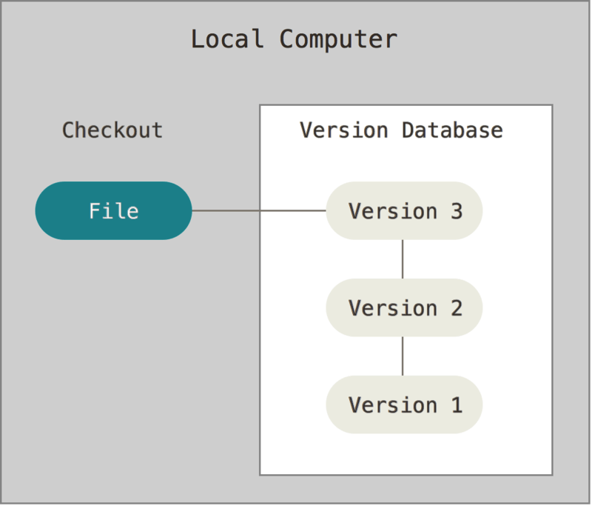 | 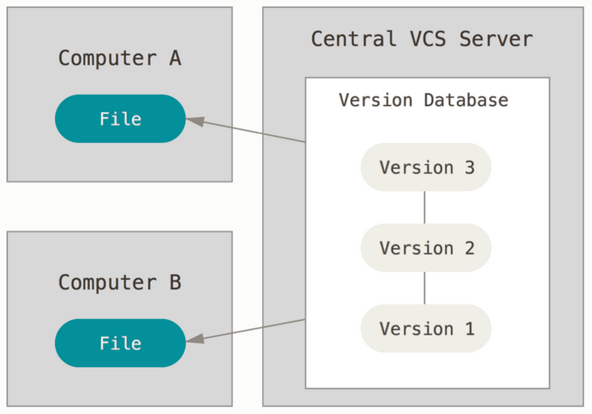 | 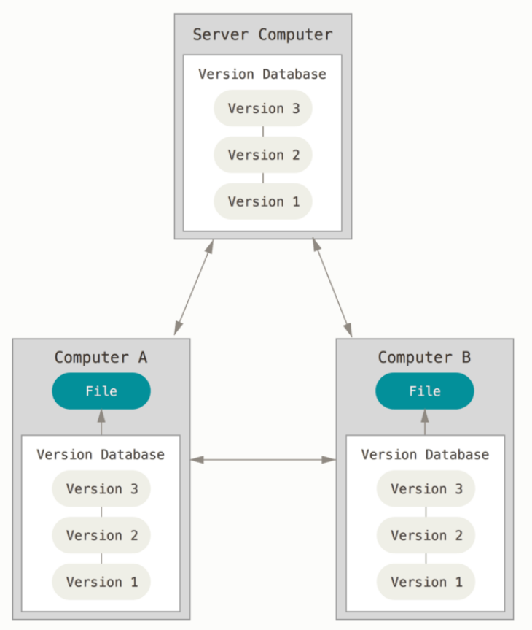
Local version control | Centralized version control | Distributed version control

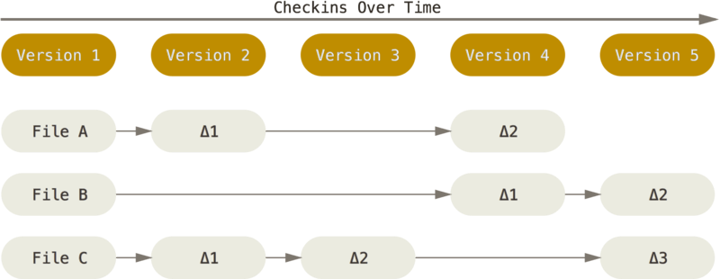 | 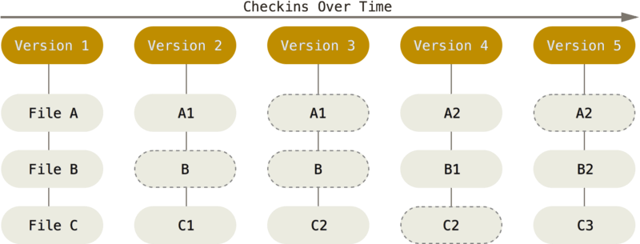
Storing data as changes to a base version of each file. | Storing data as snapshots of the project over time.
The Three States
Git has three main states that your files can reside in: modified, staged, and committed:
- Modified means that you have changed the file but have not committed it to your database yet.
- Staged means that you have marked a modified file in its current version to go into your next commit snapshot.
- Committed means that the data is safely stored in your local database.
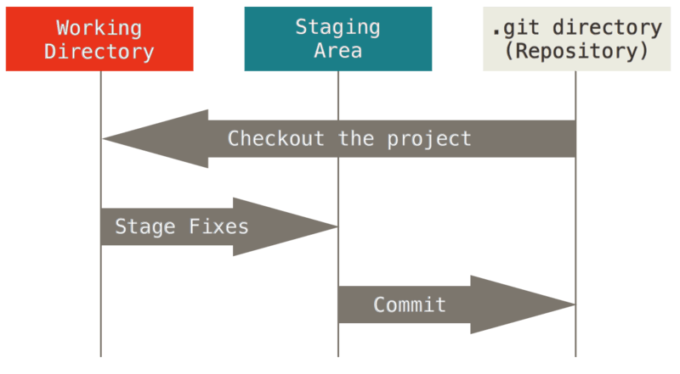 | 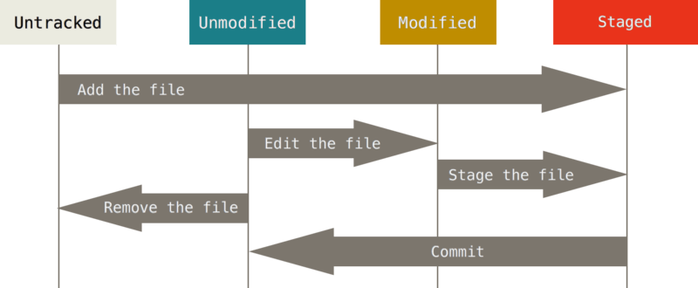
Working tree, staging area, and Git directory. | The lifecycle of the status of your files.

Git Ukazi / Git commands
Git command | Use example
git clone | $ git clone git://git.kernel.org/pub/scm/git/git.git | Clones online repository
git config | $ git config --global user.name "John Doe"  $ git config --global user.email johndoe@example.com  $ git config --global core.editor "emacs" | Configure git tool  setting user.name  setting user.email  setting default code editor
git help | $ git help config | Shows help pages for a given command
git init | $ git init | Initialised empty git repository
git commit | $ git commit -m 'initial project version'  $git commit --amend -m “initial project version revised” | Commits staged changes to the repository  Commits staged changes to the repository as part of previous commit
git status | $ git status  $ git status -s | Shows you which files are in which state
git diff | $ git diff | To see what you’ve changed but not yet staged
git rm | $ git rm readme.md  $ git rm --cached readme.md | Removes the file from the working directory and removes it from tracked files.  Keeps the file in working dir but removes it from tracked files.
git log | $ git log  $ git log --oneline --decorate --graph --all | Lists the commits made in that repository in reverse chronological order;
git reset | $ git reset HEAD CONTRIBUTING.md | Unstaging staged files
git checkout | $ git checkout -- CONTRIBUTING.md | Unfodifying modified files
git remote | $ git remote -v  $ git remote -v | Showing remotes
git push | $ git push  $ git push origin main | Pushing changes to remortes
git branch | $ git branch testing  $ git branch -u origin/serverfix  $ git branch -v  $ git branch -vv  $ git branch --merged  $ git branch --no-merged | Creates new branch testing  Current branch set up to track remote branch serverfix from origin. This creates a “tracking branch” where the branch it tracks is called “upstream branch”.  Shows the last commit on each branch  See what tracking branches you have set up.  List branches that are merged into the current branch.  List branches that are not merged into current branch
git checkout  git checkout -b  git switch  git switch -c | $ git checkout main  $ git checkout -b <name of new branch>  git checkout -b serverfix origin/serverfix | Switches to main branch  Creating new branch and switching to this branch  This gives you a local branch that you can work on that starts where origin/serverfix is.
git merge | $git merge <branch name> | Will merge <branch name> to branch you are currently on.

Tasks / Naloge

Task 0: Configure SSH FS extension in Visual Studio Code by following these steps:  1.) Click on Extensions icon in the left toolbar and search for sshfs.  2.) Install extension ssh FS (see figure below). | Naloga 0: Nastavite razširitev SSH FS v programu Visual Studio Code po naslednjih korakih:  1.) Kliknite ikono Extensions v levi orodni vrstici in poiščite sshfs.  2.) Namestite razširitev SSH FS (glejte spodnjo sliko).

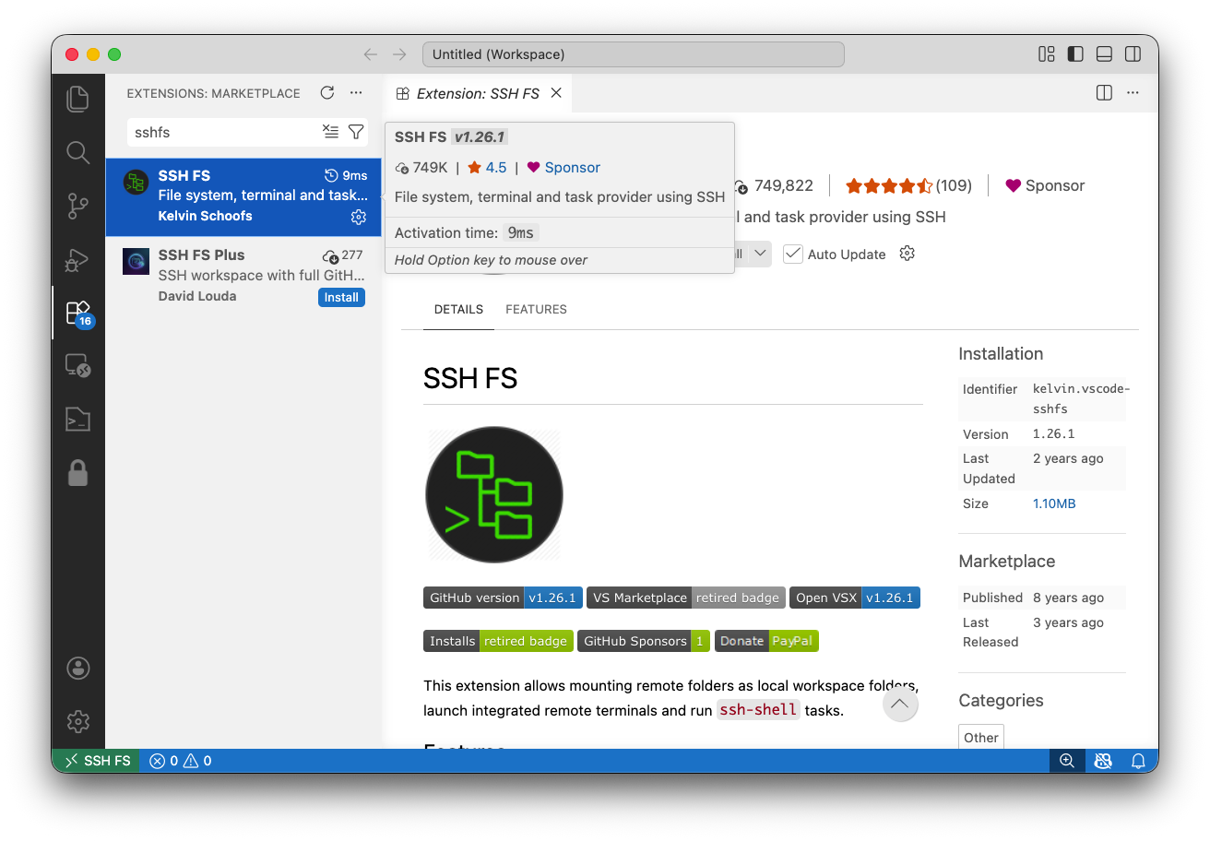

3.) Open SSH FS extension by clicking on the icon in the toolbar.  4.) Configure new connection as is shown on figure below. Make sure to enter Name, Host, Root in Port. | 3.) Odprite razširitev SSH FS s klikom na njeno ikono v orodni vrstici.  4.) Nastavite novo povezavo, kot je prikazano na spodnji sliki. Pazite, da vnesete Name, Host, Root in Port.
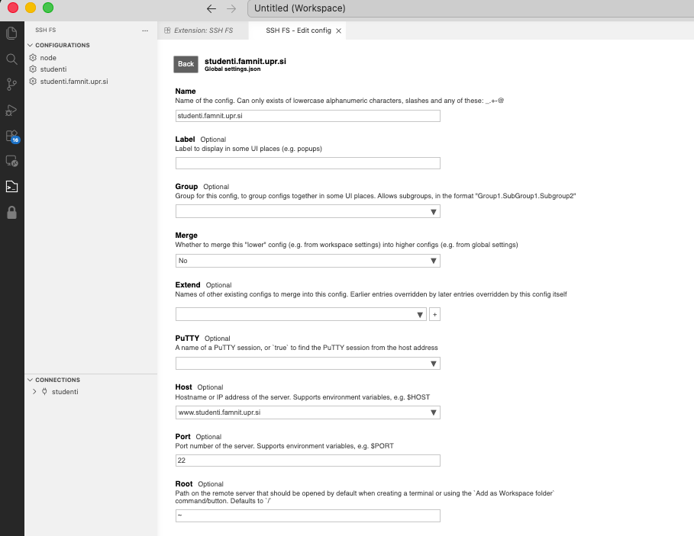

5.) Connect by clicking on the folder icon. | 5.) Povežite se s klikom na ikono mape.
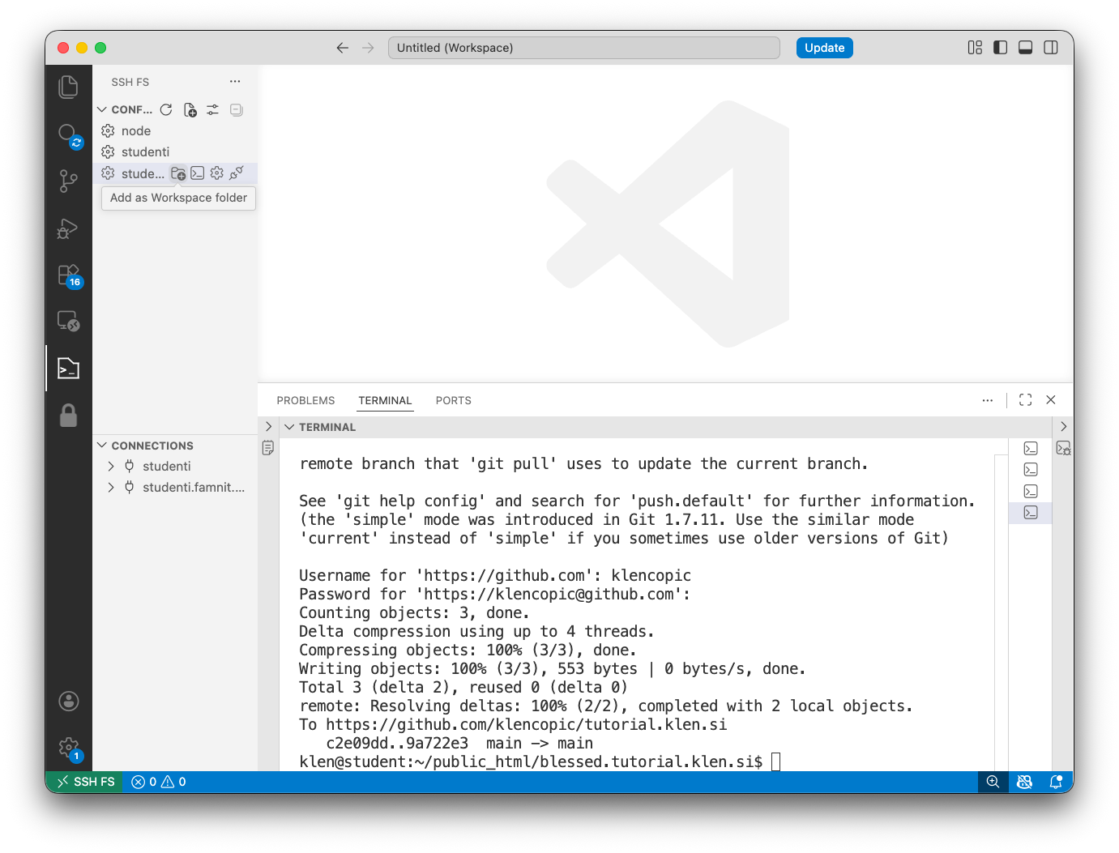

6.) You will be prompted for username and password. Enter same credentials as for logging in to lab computers. | 6.) Pozvani boste k vnosu uporabniškega imena in gesla. Vnesite enake prijavne podatke kot za prijavo v računalniški učilnici.
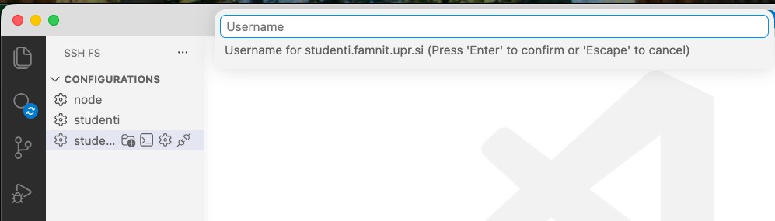

Task 1: Configure git on a global scale. Verify that the configuration of the fields below was successful.  user.name  user.email  Get help from the command table Git Ukazi / Git commands or website:  https://git-scm.com/book/en/v2/Getting-Started-First-Time-Git-Setup | Naloga 1: Nastavite Git na globalni ravni. Preverite, ali je bila nastavitev spodnjih polj uspešna.  user.name  user.email  Pomagajte si s tabelo ukazov Git Ukazi / Git commands ali s spletno stranjo:  https://git-scm.com/book/en/v2/Getting-Started-First-Time-Git-Setup

The solution to the task:
git config --global user.name "Klen"
git config --global user.email "klen.copic@example.com"

Task 2: Create a directory and initialise a git repository in it. Add the README file to the directory and save the changes to the local repository. Check change history. You should save change history into a file named task2.txt.  Get help from the command table Git Ukazi / Git commands or website:  https://git-scm.com/book/en/v2/Git-Basics-Getting-a-Git-Repository | Naloga 2: Ustvarite direktorij in v njem inicializirajte repozitorij Git. V imenik dodajte datoteko README in shranite spremembe v lokalni repozitorij. Preverite zgodovino sprememb. Zgodovino sprememb shranite v datoteko z imenom task2.txt.  Pomagajte si s tabelo ukazov Git Ukazi / Git commands ali s spletno stranjo:  https://git-scm.com/book/en/v2/Git-Basics-Getting-a-Git-Repository

The solution to the task:
# Create a new directory
mkdir task2_repo

# Move into the directory
cd task2_repo

# Initialize a Git repository
git init

# Create a README file
echo "# Task 2 Repository" > README.md

# Add README file to staging area
git add README.md

# Commit the changes to local repository
git commit -m "Add README file"

# Check change history and save it to task2.txt
git log > task2.txt

Task 3: Create a github account and verify it by following these steps:  - Create a GitHub account at https://github.com/.  - Go to GitHub Education and apply as a student.https://github.com/education  - Verify your student status with a school email or other proof of enrollment.  - Wait for approval.  - After approval, the student benefits appear on your account.  Create a new project called "my website". Clone the project and add the index.html file to it. The file should contain some html code. Save changes to local and remote repository. Check gitlab.com to verify the changes have been made successfully. Save screenshot of gitlab repository as task3.png.  Get help from the command table Git Ukazi / Git commands or website:  https://git-scm.com/book/en/v2/Git-Basics-Working-with-Remotes | Naloga 3: Ustvarite račun na GitHubu in ga potrdite po naslednjih korakih:  - Ustvarite račun GitHub na naslovu https://github.com/.  - Pojdite na GitHub Education in se prijavite kot študent: https://github.com/education  - Potrdite svoj študentski status s šolskim e-poštnim naslovom ali drugim dokazilom.  - Počakajte na odobritev.  - Po odobritvi se bodo študentske ugodnosti prikazale na vašem računu.  Ustvarite nov projekt z imenom "my website". Klonirajte projekt in vanj dodajte datoteko index.html. Datoteka naj vsebuje nekaj kode HTML. Spremembe shranite v lokalni in oddaljeni repozitorij. Preverite na github.com, ali so bile spremembe uspešno izvedene. Posnetek zaslona repozitorija GitHub shranite kot task3.png.  Pomagajte si s tabelo ukazov Git Ukazi / Git commands ali s spletno stranjo:  https://git-scm.com/book/en/v2/Git-Basics-Working-with-Remotes

Task 4: Using GIT follow this scenario:  Work on the website tutorial.klen.si  Git repo: https://github.com/klencopic/tutorial.klen.si  - Create a branch iss53 for a new user story.  - In iss53, add a new News menu item and a new News section on the page.  While working, you are interrupted by a critical production issue. The problem is UTF-8 encoding which results in incorrect display of “Čopič” as ”??opi??” (see figure below). You'll do the following:  - Switch to the main branch.  - Create a branch hotfix.  - Fix the UTF-8 encoding issue that displays Čopič as ??opi??.  - Test the fix, merge hotfix into main.  - Create your new remote repository and push the changes to this remote.  - Switch back to iss53 and finish your work on the user story. | Naloga 4: Z uporabo GIT sledite scenariju:  Delajte na spletni strani tutorial.klen.si  Git repozitorij: https://github.com/klencopic/tutorial.klen.si  - Ustvarite vejo iss53 za novo uporabniško zgodbo.  - V veji iss53 dodajte nov element menija News in nov razdelek News na strani.  Med delom vas prekine kritična produkcijska napaka. Težava je v kodiranju UTF-8, zaradi česar se »Čopič« nepravilno prikaže kot »??opi??« (glejte spodnjo sliko). Nato izvedite naslednje korake:  - Preklopite na glavno vejo main.  - Ustvarite vejo hotfix.  - Odpravite težavo s kodiranjem UTF-8, zaradi katere se Čopič prikazuje kot ??opi??.  - Preizkusite popravek in združite vejo hotfix v main.  - Ustvarite svoj novi oddaljeni repozitorij in potisnite spremembe v ta repozitorij.  - Preklopite nazaj na vejo iss53 in dokončajte delo na uporabniški zgodbi.

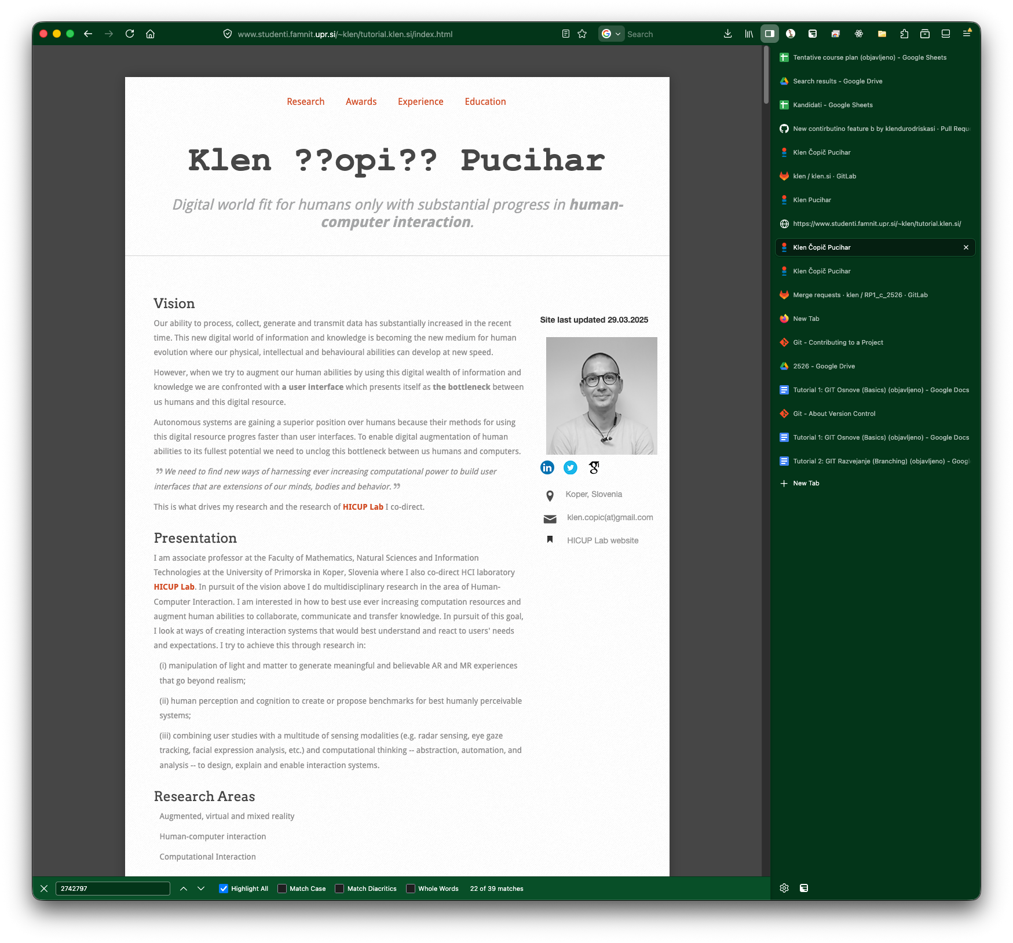
Figure 1: Website screenshot with evident error.
Slika 1: Posnetek zaslona spletne strani z očitno napako.

Generate .txt file providing the output of the  $ git log --oneline --decorate --graph --all  For help refer to GIT Ukazi / GIT Commands or website Basic Branching and Merging. | Ustvarite datoteko .txt, ki vsebuje izpis ukaza  $ git log --oneline --decorate --graph --all.  Za pomoč si oglejte Git Ukazi / Git commands ali spletno stran Basic Branching and Merging.

The solution to the task:
# clone the repository
git clone https://github.com/klencopic/tutorial.klen.si.git
cd tutorial.klen.si

# create and switch to the user-story branch
git switch -c iss53

# edit index.html
# add a new "News" menu item
# add a new "News" section on the page

git add index.html
git commit -m "Add News menu item and News section"

# interrupted by production issue: go back to main
git switch main

# create hotfix branch from main
git switch -c hotfix

# fix UTF-8 issue in index.html
# and correct the broken text so it shows "Čopič"

git add index.html
git commit -m "Fix UTF-8 encoding for Čopič"

# test the fix locally by opening index.html file
# after verifying, merge hotfix into main
git switch main
git merge hotfix

# optionally delete the temporary hotfix branch
git branch -d hotfix

# create your own empty remote repository on GitHub first,
# then connect it as a new remote
git remote rename origin upstream
git remote add origin https://github.com/YOUR-USERNAME/tutorial.klen.si.git

# push main to your new remote
git push -u origin main

# go back to the user-story branch
git switch iss53

# finish the user-story work if anything is still missing
git add index.html
git commit -m "Finish News feature"

# push iss53 too
git push -u origin iss53

Task 5 (optional): Deploying solutions from task 4 using GIT.  Deploy the website developed in task 4 to student server www.studenti.famnit.upr.si.  You will need to:  - Clone repository from task4 to student server in directory ~/public_html/tutorial.klen.si. This is now your live (production) website.  Visit the website at: www.studenti.famnit.upr.si/~[enrolment_number]/tutorial.klen.si  Now you got an additional task. You need to integrate the work from branch iss53 using Git. Because the website is popular, first deploy and test the changes in a development copy before updating the live site. Both the development and production versions are hosted on the same server, www.studenti.famnit.upr.si, but in different directories:  - Development site: ~/public_html/devel/  - Production site: ~/public_html/tutorial.klen.si/  Save the full history of commands to a file named task5.txt. You can do this with using cat ~/.bash_history.  HINT: You need to follow these steps:  - Deploy the website to the development site in ~/public_html/devel/.  - Test the additional feature from issue53.  - Merge the changes into the main branch.  - Deploy the updated version to the production site in ~/public_html/tutorial.klen.si/. | Naloga 5 (dodatno): Nameščanje rešitev iz naloge 4 z uporabo GIT.  Spletno stran, razvito v nalogi 4, namestite na študentski strežnik www.studenti.famnit.upr.si.  Potrebovali boste:  - Klonirati repozitorij iz naloge 4 na študentski strežnik v imenik ~/public_html/tutorial.klen.si. To bo zdaj vaša delujoča (produkcijska) spletna stran.  Spletno stran obiščite na naslovu:  www.studenti.famnit.upr.si/~[vpisna_številka]/tutorial.klen.si  Zdaj ste dobili dodatno nalogo. Delo iz veje iss53 morate integrirati z uporabo Gita. Ker je spletna stran priljubljena, spremembe najprej namestite in preizkusite v razvojni kopiji, preden posodobite delujočo stran. Tako razvojna kot produkcijska različica gostujeta na istem strežniku, www.studenti.famnit.upr.si, vendar v različnih imenikih:  - Razvojna stran: ~/public_html/devel/  - Produkcijska stran: ~/public_html/tutorial.klen.si/  Celotno zgodovino ukazov shranite v datoteko z imenom task5.txt. To lahko naredite z ukazom cat ~/.bash_history.  NAMIG: Slediti morate naslednjim korakom:  - Namestite spletno stran na razvojno stran v ~/public_html/devel/.  - Preizkusite dodatno funkcionalnost iz issue53.  - Združite spremembe v glavno vejo main.  - Posodobljeno različico namestite na produkcijsko stran v ~/public_html/tutorial.klen.si/.

The solution to the task:
#Deploy the production website to the student server

ssh [enrolment_number]@www.studenti.famnit.upr.si
cd ~/public_html
git clone https://github.com/YOUR-USERNAME/tutorial.klen.si.git tutorial.klen.si
cd tutorial.klen.si
git switch main
#Deploy the development copy on the same server

cd ~/public_html
git clone https://github.com/YOUR-USERNAME/tutorial.klen.si.git devel
cd devel
git switch iss53

#Test the additional feature from iss53
Open website at: www.studenti.famnit.upr.si/~[enrolment_number]/devel/
#Merge iss53 into main
cd tutorial.klen.si
git switch main
git merge iss53
git push origin main
#Update the production deployment
ssh your_username@www.studenti.famnit.upr.si
cd ~/public_html/tutorial.klen.si
git pull origin main

Tutorial 2: GIT Veje / GIT Branching

3. Git Branching

3.1 Branches in a Nutshell

3.2 Basic Branching and Merging

3.3 Branch Management

3.4 Branching Workflows

3.5 Remote Branches

3.6 Rebasing

3.7 Summary

5. Distributed Git

5.1 Distributed Workflows

5.2 Contributing to a Project

5.3 Maintaining a Project

5.4 Summary

Povzetek / Summary

GIT BRANCHING

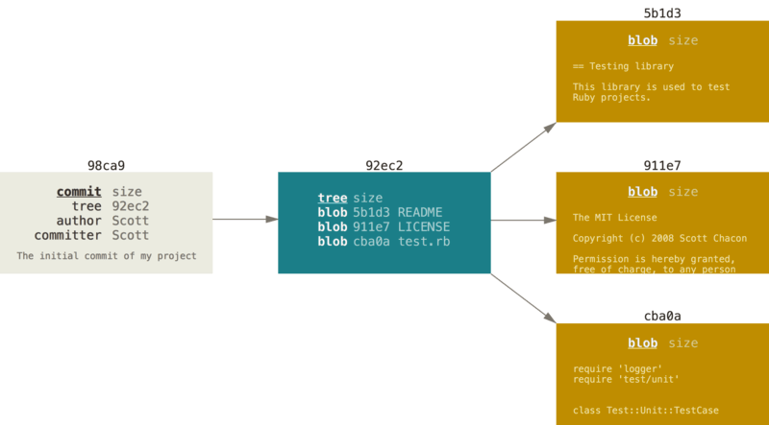
Commit in drevo / A commit and its tree
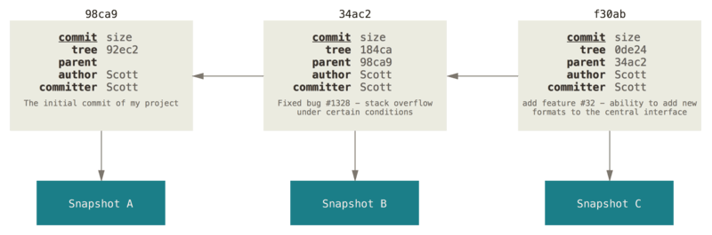
Commits in njihovi starši / Commits and their parents

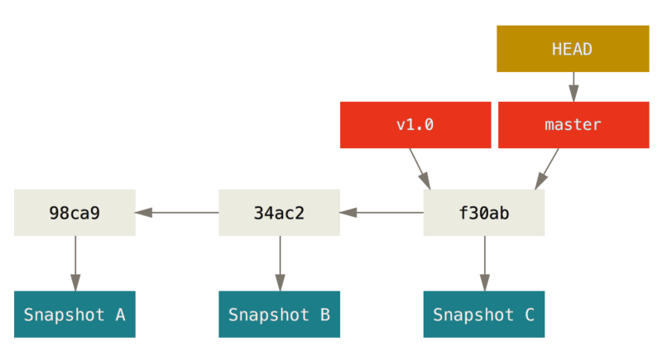 | 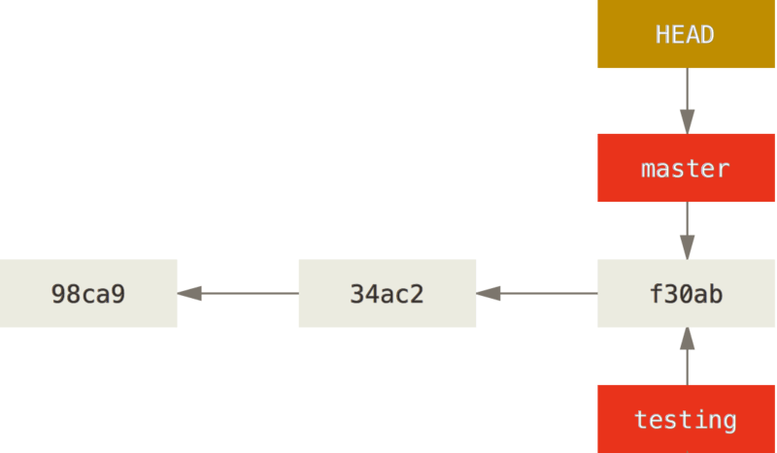
Veja in njena zgodovina commit-ov  A branch and its commit history. | Dve veji, ki kažeta na isti commit in HEAD ki kaže na vejo master.  Two branches pointing into the same commit and HEAD pointing at master branch.
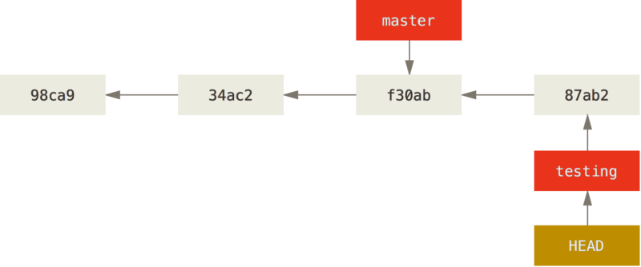 | 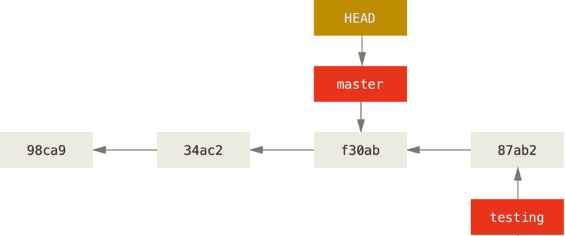
HEAD veja se pomakne naprej ko se ustvari nov commit.  The HEAD branch moves forward when a commit is made. | HEAD se premakne ko izvedemo checkout  HEAD moves when you checkout.
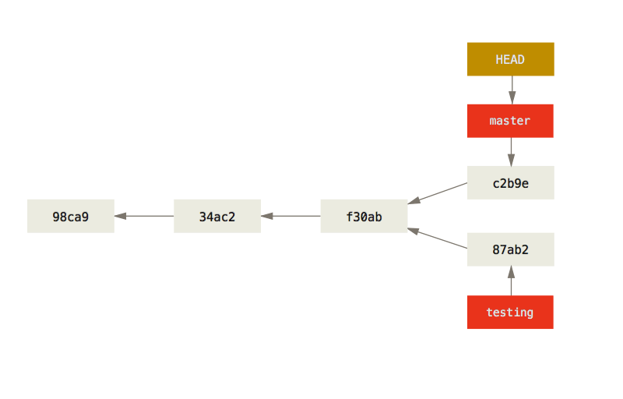 | 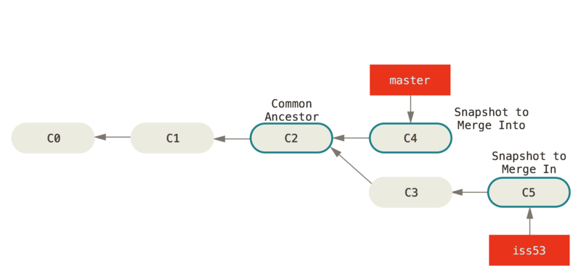
Divergenca v zgodovini / Divergent history | Trije snapshoti uporabljeni v tipičnem združevanju vej, ko ni skupnega starša (merge).  Three snapshots used in a typical merge where branches do not hold common parent.

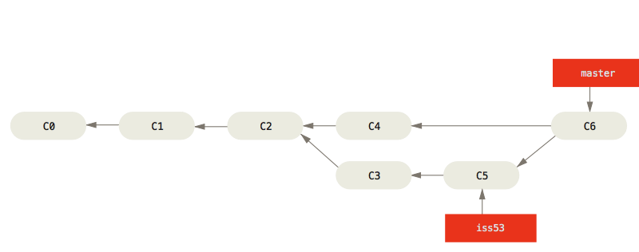
Commit ob združevanju vej / A merge commit

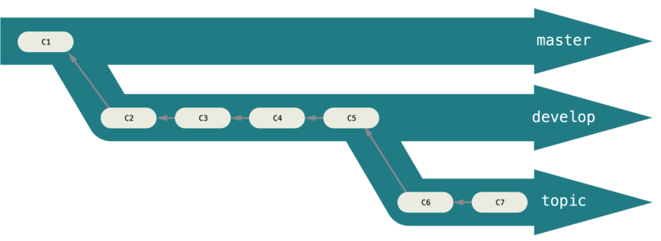
A “silo” view of progressive-stability branching

Rebasing

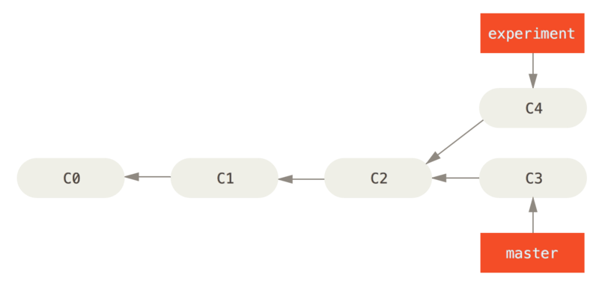 | 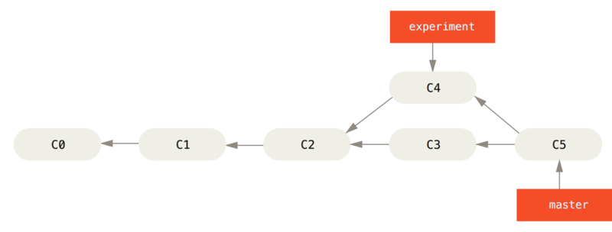
Simple divergent history | Merging to integrate diverged work history
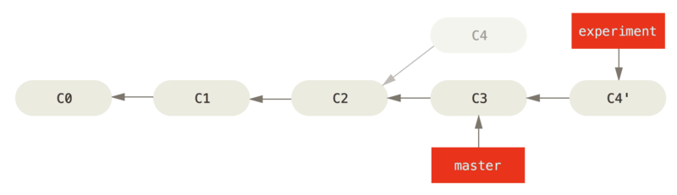 | 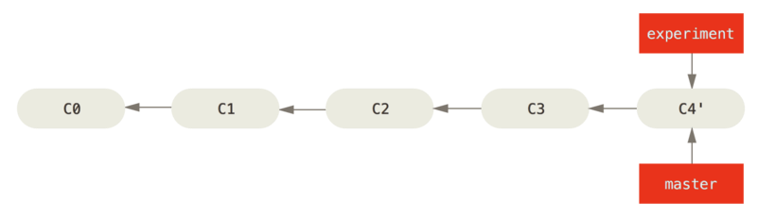
Rebasing the change introduced in C4 onto C3 | Fast-forwarding the master branch

Tracking branches

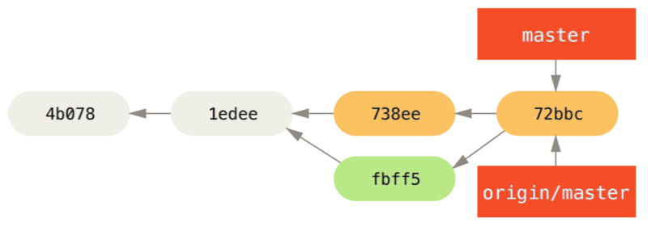DISTRIBUTED GIT

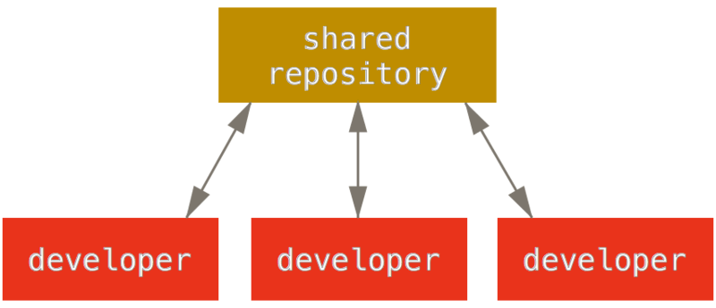 | 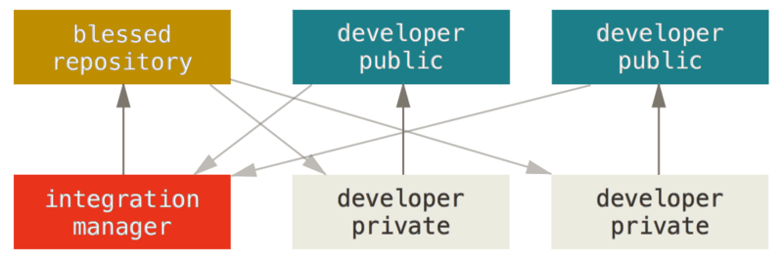 | 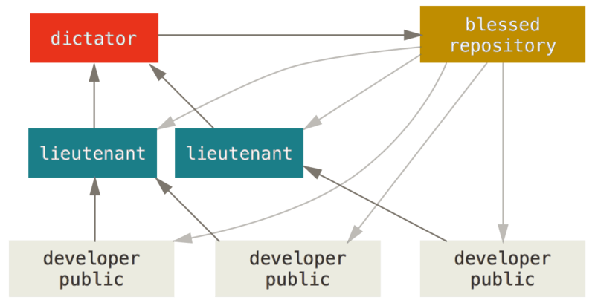
Centralized Workflow | Integration-manager workflow. | Benevolent dictator workflow.

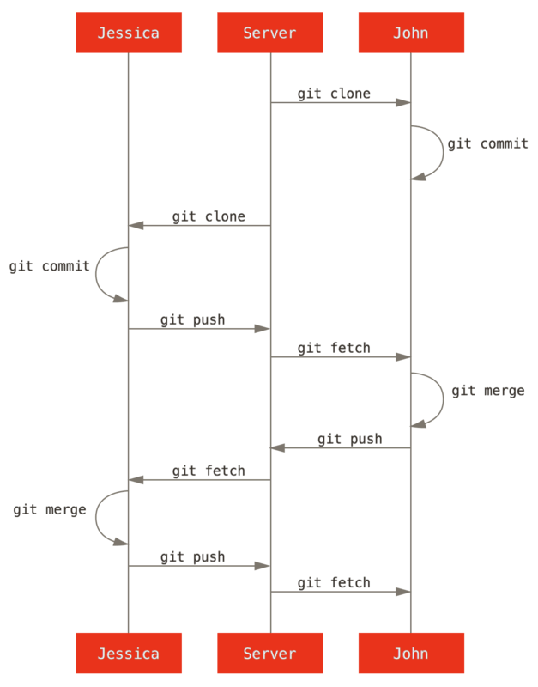 | 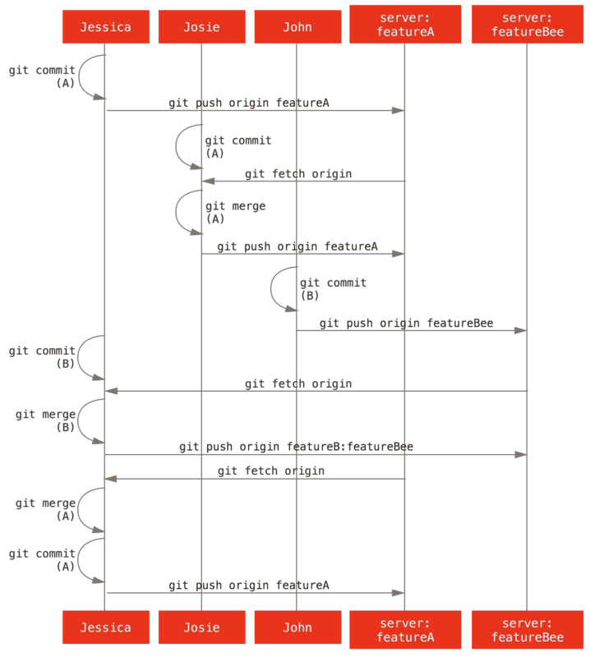
General sequence of events for a simple multiple-developer centralized Git workflow. | Basic sequence of this managed-team workflow.
When contributing to public projects one needs to reside to create a fork. The fork is then integrated into the main project by the project maintainer.

GIT Ukazi / GIT Commands
Git command | Use example
git branch | $ git branch testing  $ git branch -u origin/serverfix  $ git branch -v  $ git branch -vv  $ git branch --merged  $ git branch --no-merged | Creates new branch testing  Current branch set up to track remote branch serverfix from origin. This creates a “tracking branch” where the branch it tracks is called “upstream branch”.  Shows the last commit on each branch  See what tracking branches you have set up.  List branches that are merged into the current branch.  List branches that are not merged into current branch
git checkout  git checkout -b  Alternative:  git switch  git switch -c | $ git checkout master  $ git checkout -b <name of new branch>  git checkout -b serverfix origin/serverfix | Switches to master branch  Creating new branch and switching to this branch  This gives you a local branch that you can work on that starts where origin/serverfix is.
git log | $ git log --oneline --decorate --graph --all | Shows divergence history
git merge | $git merge <branch name> | Will merge <branch name> to branch you are currently on.
git mergetool | $ git mergetool | Opens up mergetool for resolving conflicts.
git push <remote> <branch>  git push <remote> <branch>:<branch_name_on_server> | $ git push origin serverfix  $ git push origin serverfix:new_serverfix  $ git push -u origin devel  $ git push --set-upstream origin devel | Pushes local branch serverfix to the remote  Pushes local branch serverfix to the remote as branch new_serverfix  Pushes local branch to the remote as branch origin/devel  Create and setup new remote branch with the current branch
git fetch | $ git fetch  $ git fetch --all; | Will fetch all changes from current remote branch, but it will not modify your working directory.  Will fetch for all the changes from all your remotes and branches.
git pull | $ git pull  Alternative:  $ git fetch  $ git merge | will look up what server and branch your current branch is tracking, fetch from that server and then try to merge into local branch.

Task 6: Generate a git repository with two branches main and experiment. Add commits so you have a simple divergent history. Rebase and merge experiment into main.  Submit task6.txt with the output of git log --oneline --decorate --graph --all  For help refer to GIT Ukazi / GIT Commands or websites Rebasing. | Naloga 6: Ustvarite Git repozitorij z dvema vejama, main in experiment. Dodajte potrditve sprememb, tako da dobite preprosto razvejano zgodovino. Nato izvedite rebase in združite vejo experiment v main.  Oddajte datoteko task6.txt, ki vsebuje izpis ukaza git log --oneline --decorate --graph --all.  Za pomoč si oglejte GIT Ukazi / GIT Commands ali spletno stran Rebasing.

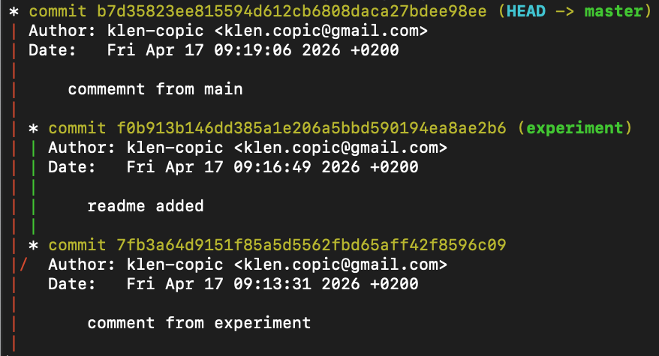 | 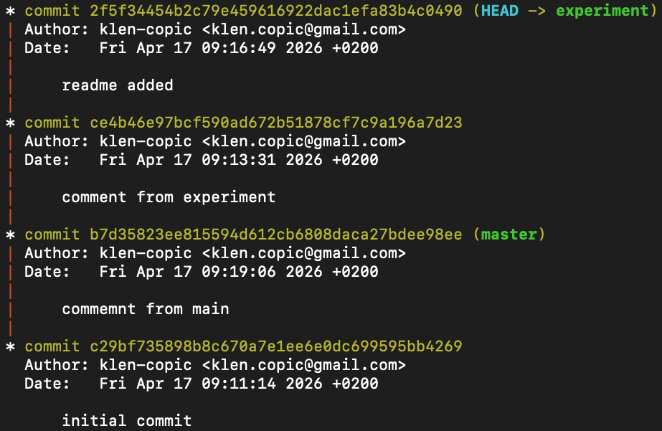
State of history before rebase.  Stanje zgodovine pre rebase. | State of history after rebase.  Stanje zgodovine po rebase.

The solution to the task:
# create a new repository
mkdir task6
cd task6
git init -b main

# first commit on main
echo "# Task 6" > README.md
git add README.md
git commit -m "Initial commit on main"

# second commit on main
echo "Main line work 1" > main.txt
git add main.txt
git commit -m "Add main.txt"

# create experiment branch
git switch -c experiment

# commits on experiment
echo "Experiment work 1" > experiment.txt
git add experiment.txt
git commit -m "Add experiment.txt"

echo "Experiment work 2" >> experiment.txt
git add experiment.txt
git commit -m "Update experiment.txt"

# switch back to main and make main diverge
git switch main
echo "Main line work 2" >> main.txt
git add main.txt
git commit -m "Update main.txt"

# rebase experiment onto main
git switch experiment
git rebase main

# merge experiment into main
git switch main
git merge experiment
# save the required output
git log --oneline --decorate --graph --all > task6.txt

Task 7 (optional): Contributing to a public project  Fork project on blessed repository https://github.com/klencopic/tutorial.klen.si. Clone forked repository and add a new branch “featureA”, do some work on the branch by changing index.html and store your changes in local and forked repository. Rebase feature A on main. Once you are done create a pull request asking the owner of the repository to merge your branch featureA with main branch on the original repository.  Now act like integration manager. Clone blessed repository bring changes from the forked remote to your local repository. Test to make sure solution is good and integrate it into main branch of you local version of blessed repository. The final step of pushing changes to the blessed repository is not possible, as you do not have the rights to write to blessed repository.  To do this follow instructions on forking public project (see section Forked Public Project). https://git-scm.com/book/en/v2/Distributed-Git-Contributing-to-a-Project  Generate a screenshot of the website showing you successfully forked and integrated your changes into forked repository. | Naloga 7 (dodatno): Prispevanje k javnemu projektu  Naredite fork projekta iz izvornega repozitorija https://github.com/klencopic/tutorial.klen.si. Klonirajte svoj forkani repozitorij in ustvarite novo vejo featureA. V tej veji opravite nekaj dela tako, da spremenite datoteko index.html, nato pa spremembe shranite v lokalni in forkani repozitorij. Izvedite rebase veje featureA na main. Ko končate, ustvarite pull request, s katerim lastnika repozitorija prosite, da združi vašo vejo featureA z vejo main v izvirnem repozitoriju.  Nato prevzemite vlogo upravljalca integracije. Klonirajte izvorni repozitorij, prenesite spremembe iz forkanega oddaljenega repozitorija v svoj lokalni repozitorij, preverite, ali je rešitev ustrezna, in jo združite v vejo main svoje lokalne različice izvornega repozitorija. Zadnji korak, to je potisk sprememb v izvorni repozitorij, ni mogoč, saj nimate pravic za pisanje v izvorni repozitorij.  Za izvedbo sledite navodilom za forkanje javnega projekta (glejte razdelek Forked Public Project):  https://git-scm.com/book/en/v2/Distributed-Git-Contributing-to-a-Project  Pripravite tudi posnetek zaslona spletne strani, ki prikazuje, da ste uspešno naredili fork in vključili svoje spremembe v forkani repozitorij.

The solution to the task:
#Create a fork
#Contributor side
git clone https://github.com/YOUR-USERNAME/tutorial.klen.si.git
cd tutorial.klen.si
git remote add upstream https://github.com/klencopic/tutorial.klen.si.git
git switch main
git pull origin main
git switch -c featureA
nano index.html

#Make some changes to index.html
git add index.html
git commit -m "Add featureA changes to index.html"
git push -u origin featureA
git fetch upstream
git rebase upstream/main
git push --force-with-lease origin featureA

#Integration manager side
git clone https://github.com/klencopic/tutorial.klen.si.git blessed-tutorial
cd blessed-tutorial
git remote add contributor https://github.com/YOUR-USERNAME/tutorial.klen.si.git
git fetch contributor
git switch -c review-featureA contributor/featureA

#Test index.html
git switch main
git pull origin main
git merge review-featureA

All task solutions should be submitted to famnit website. Submissions are not evaluated.
Vse rešitve nalog je treba oddati na spletni strani FAMNIT. Oddaje se ne ocenjujejo

